**Experiment 3 :** Build a mobile application for controlling the peripheral devices via Bluetooth

Aim:

The aim of this Experiment is to Build a mobile application for controlling the peripheral devices via Bluetooth

**2.SOFTWARE**

MIT App Inventor is a web application integrated development environment originally provided by Google, and now maintained by the Massachusetts Institute of Technology

2.1 GET START WITH MIT APP Inventor

Follow the steps to Login MIT APP Inventor:

Step 1: Browse for the URL - ' https://appinventor.mit.edu/'

Step 2: Go to App Inventor and open a project (or create a new one — use Project > Start New Project and give your project a name)

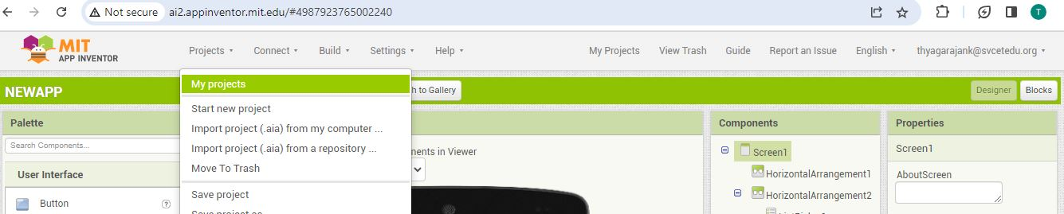

Step 3: Use a horizontal arrangement component to display this component from left to right in the Mobile Display.

Step 4: Go to Properties Set *AlignHorizontal(*option).In this the choices are: **1 = left aligned**, 2 = right aligned, 3 = horizontally cantered. Alignment has no effect if the Horizontal Arrangement’s Width is Automatic.

Step 5: Go to Properties Set **AlignVertical.** **The choices are: 1 = aligned at the top**, **2 =** vertically centered, 3 = aligned at the bottom. Alignment has no effect if the HorizontalArrangement’s Height is Automatic.

Step 6: Specifies the background color of the HorizontalArrangement as an alpha-red-green-blue integer.

Step 7: Specifies the HorizontalArrangement’s vertical height, measured in100 pixels.

Step 8 : Specifies the horizontal width of the HorizontalArrangement, measured in 100 percent.

Step 9: repeat the step 3 to 8

Step 10 : In User Interface – Select -ListPicker -Is a button that, when clicked on,

displays a list of texts for the user to choose among.

Step 11 : Go to Properties Specifies the ListPicker’s background color as an alpha-red-green-blue integer.

Step 12 : Specifies the text displayed by the ListPicker as SCAN FOR DEVICE and **TextAlignment as** 1 (center)

Step 13: Specifies the text color of the ListPicker as an alpha-red-green-blue integer.

Step 14: repeat the step 3 to 8

Step 15: In User Interface – Select-Button-Button with the ability to detect clicks

Step 16 : Go to Properties Specifies the Button background color as an alpha-red-green-blue integer.

Step 17 : Specifies the text displayed by the Button as TURN ON and **TextAlignment as** 1 (center)

Step 18: In User Interface – Select-Button- Go to Properties Specifies the Button background color as an alpha-red-green-blue integer.

Step 19 : Specifies the text displayed by the Button as TURN OFF and **TextAlignment as** 1 (center)

Step 20 : Select Connectivity -Drag and drop in Mobile display Its Use BluetoothClient to connect your device to other devices using Bluetooth.

**User Interface in Mobile :**

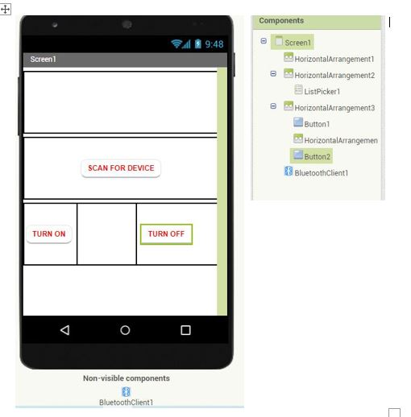

Code: Go to Blocks and Drag and drop the respective code as give bellow.

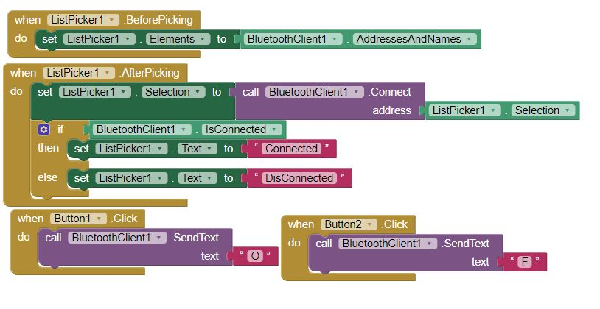

Step 21 : Go to Build option Select Android APP(.apk) which generates Android app and it need to be downloaded and installed in the mobile phone.

